Name : Vishal Jha

Batch : Data Engineering

Date : 28-02-2024

Topic – Azure Devops Coding Challenge – 01

**Create Azure Devops Environment and configuring Azure Devops Git Repository, configure on your local git to implement this upload few test files on same.**

**Step-1:** Login into your Azure account and go to the Azure DevOps Organizations Service then click My Azure DevOps Organizations

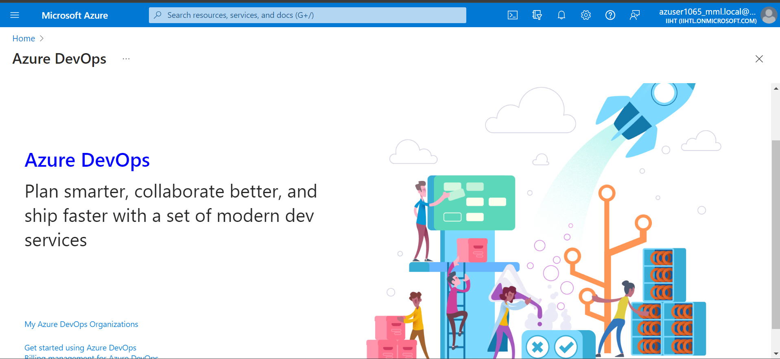

**Step-2:** Create a new project

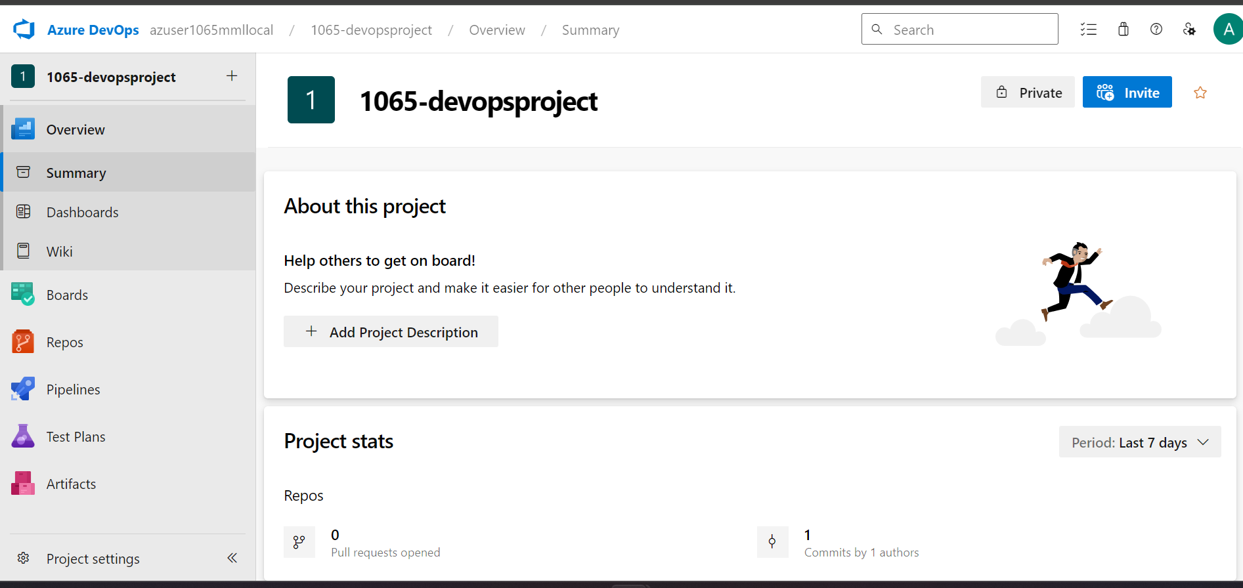

**Step-3:** Create a new repo

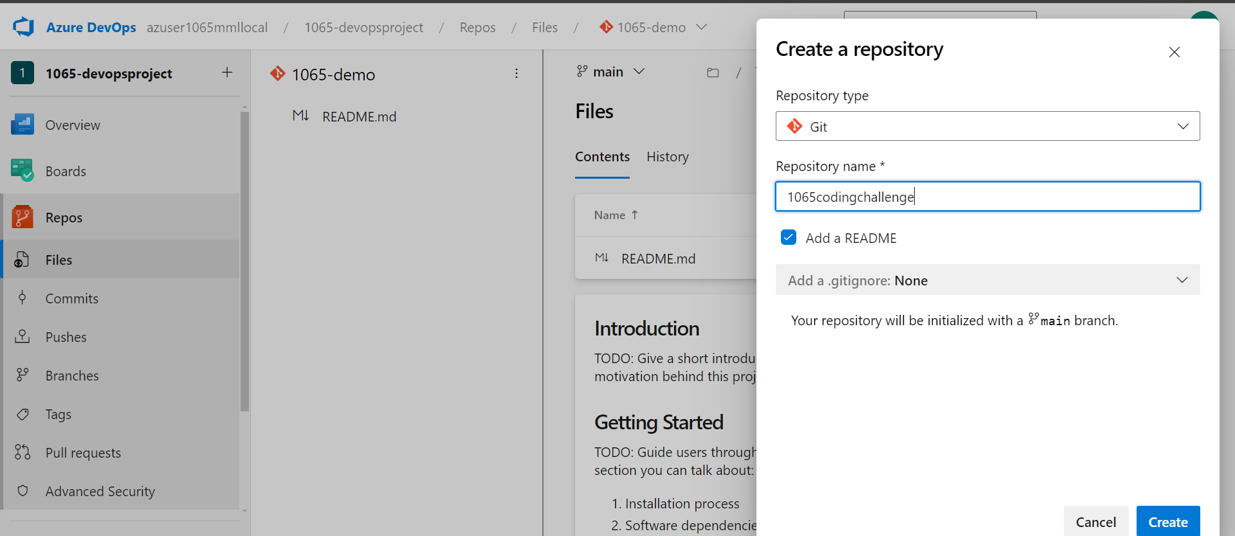

**Step-4:** Now select the clone option

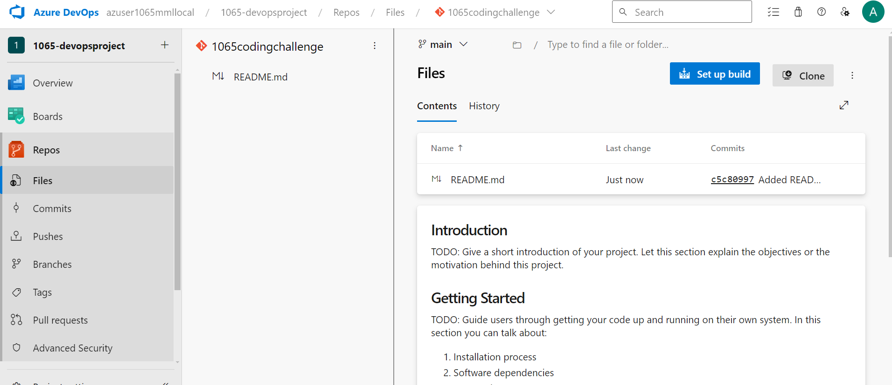

**Step-5:** Now select the clone in vs-code option

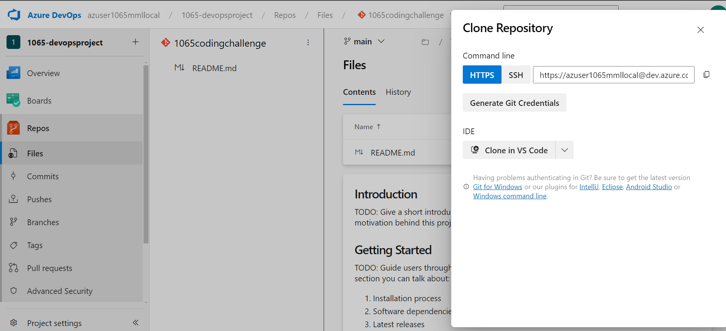

**Step-6:** You can see the cloned version on vs code studio

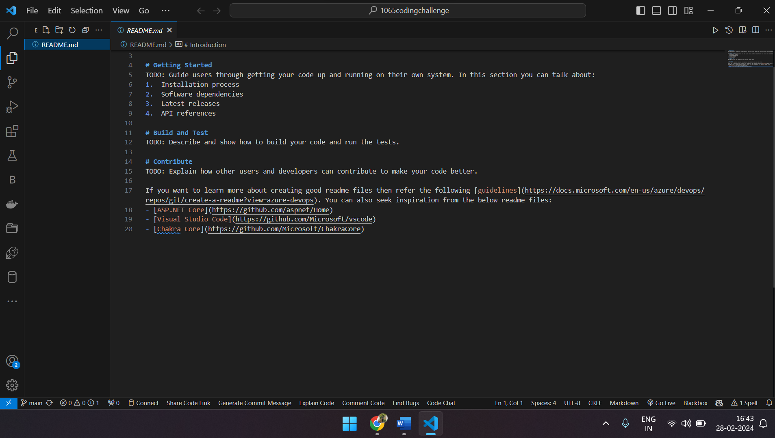

**Step-7:** Create a new file in vs code studio

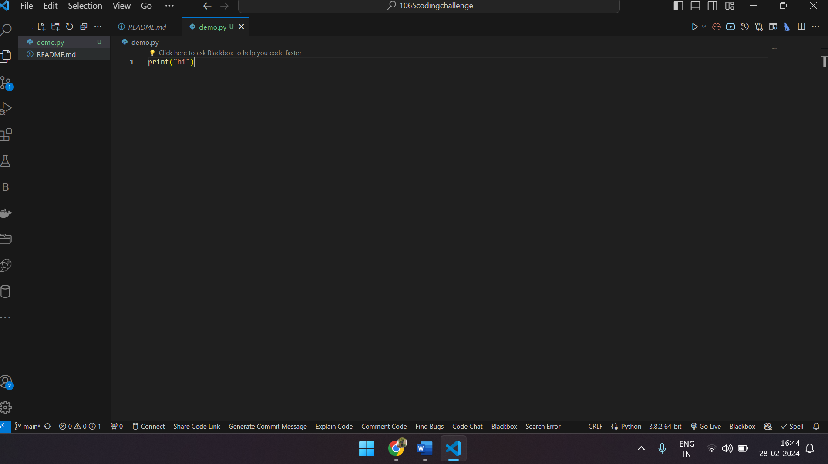

**Step-8:** Open git bash and enter the commands (on repository location).

1. git add demo.py
2. git commit -a -m “my first commit”
3. git push

**Step-9:** Now check the history in Azure DevOps Organization

